

HIV Testing

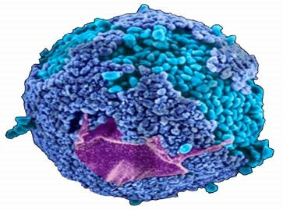 | What is HIV?  HIV is a virus that attacks the body.  It can stop your body from fighting infections and illnesses
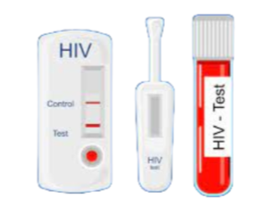 | A HIV test will tell you if you have the HIV virus.  The test involves taking some of your blood and testing it for the virus
U=U | There are good HIV treatments available that will keep someone with HIV feeling well and stop the infection getting worse.  People who have the HIV virus that take treatment are unable to pass it on to other people
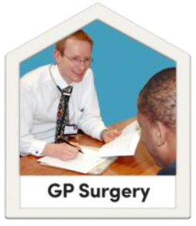  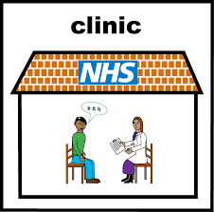 | Where to get tested for HIV  Your doctor  East Sussex Sexual Health clinic  0300 013 2050  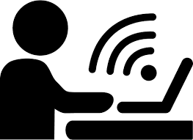  If you have had sex with a new partner, you should take a sexually transmitted infection test including HIV.  Order a test online  www.sh.uk

Easy read leaflets https://www.easyhealth.org.uk/

