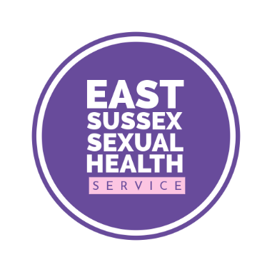

Post-exposure prophylaxis (PEP)

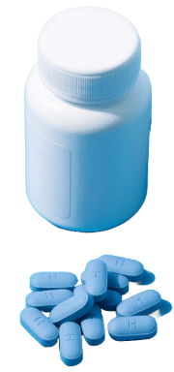 | PEP is a medication that can help prevent against the HIV virus after the infection has entered a person’s body
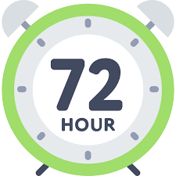 | It needs to be taken within 72 hours after coming into contact with the infection  Try and take it as soon as possible
  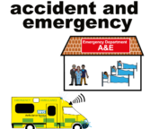  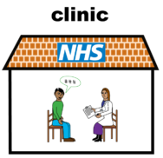 | You can get the PEP from one of our clinics in Eastbourne or Hastings  Call 0300 013 2050 if you think you might need PEP  or  You can get it from an A&E department  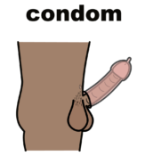  The best way to help protect yourself from HIV is to wear a condom during sex
Easy read leaflet s https://www.easyhealth.org.uk/

