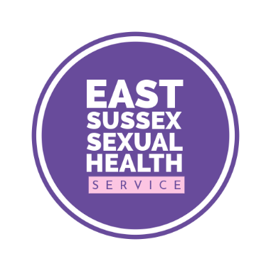

Pre-exposure prophylaxis (PrEP)

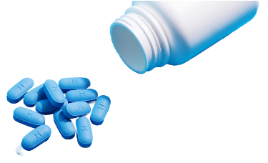  HIV | PrEP is a medication that can be taken to prevent HIV.  Taking PrEP means there is enough medicine inside of your body to block HIV if you come into contact with it
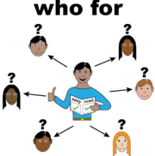 | PrEP can be taken by anyone from a group that is at risk of HIV or if you have sex with people who are at risk of HIV
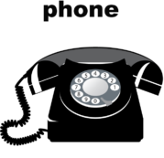  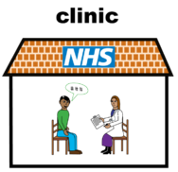 | If you think you could benefit from PrEP contact our clinics in Eastbourne or Hastings  Call 0300 013 2050 if you think you might need PrEP
Easy read leaflet s https://www.easyhealth.org.uk/

