

Sexually Transmitted Infections
(STIs)

 | An STI is an infection that is passed on when you have sex
 | An STI can make you feel very ill
 | An STI can make men and women infertile (unable to have babies)
   | What are the common infections?  Chlamydia - Usually there are no symptoms so most people don't know they have it.  Gonorrhoea - The main symptom is discharge (leaking fluid) from the penis or bottom and pain when peeing. Most women do not have symptoms.  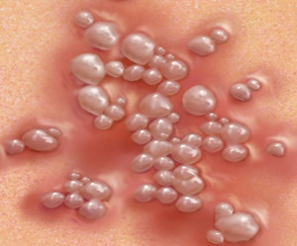  Genital herpes - The main symptom is itching around the genital area followed by blisters or sores.    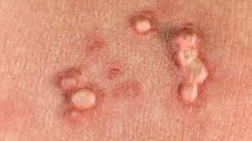  Genital warts - Warts can take about a year or more to grow. Sometimes you can't see them if they are inside the vagina or anus (bottom).  HIV and AIDS - This is a virus that is spread by having unprotected sex (e.g. no condom), sharing needles if taking drugs or by infected blood.  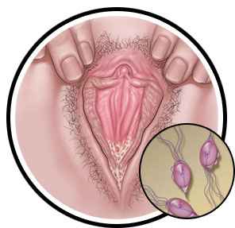  Trichomoniasis - This is when tiny parasites infect the vagina and the tube that you wee through (urethra).  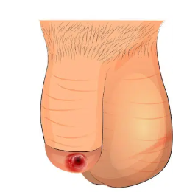  Syphilis - This starts with a sore on or near the vagina or penis, or in the mouth or anus (bottom).Followed by a rash and feeling like you have the flu.
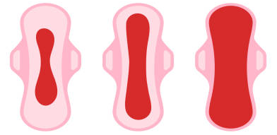  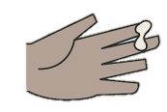  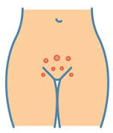  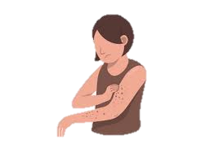 | What are the symptoms?  Different liquids coming from the vagina or penis.  Heavy periods.  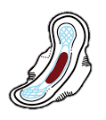  Bleeding between periods.  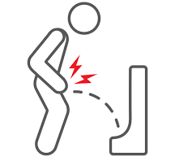  A pain or burning feeling when peeing.  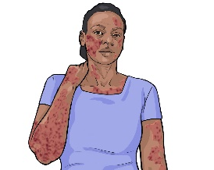  A rash.  Itching or tingling around the genitals (penis/vagina) or anus (bottom).    Some STIs have no symptoms at all.
  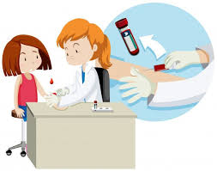   | What are the tests and treatments?  Most STIs can easily be detected and treated at local sexual health clinics.  You can telephone the clinic on 0300 013 2050 to book yourself for a check-up or test.  If you have a test, it will probably be a blood test from your arm, a urine sample or a swab from the end of the penis or the inside of the vagina.    If you do have an STI, you should tell anyone that you are having sex with like your partner, boyfriend, girlfriend, husband, wife or lover.  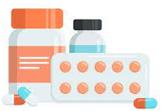  Most STIs can be treated with antibiotics (medicines).

Easy read leaflet s https://www.easyhealth.org.uk/

